Automated ECG Classification Using Hearbeat Image Based on RESNET50
Department of Computer Science and Engineering
Md Nafsun Kabir

Abstract
This study investigates the effectiveness of automated ECG classification using heartbeat images processed through a ResNet50-based deep learning framework. The dataset consists of four clinically significant classes—Abnormal Heartbeat, History of Myocardial Infarction (MI), Myocardial Infarction, and Normal—derived from real medical ECG images instead of traditional raw 1D signal recordings. Each image undergoes standardized preprocessing including resizing, normalization, and medical-image–oriented augmentation to ensure robust feature extraction. Categorical class labels were encoded, and images were transformed into normalized pixel arrays suitable for deep convolutional processing. A transfer learning approach with fine-tuned ResNet50 was trained using an 80–20 train-test split. The proposed model achieved a test accuracy of 91.91%, outperforming many traditional ECG-feature–based approaches. This study addresses limitations in previous research such as reliance on raw ECG digitization, lack of real-image evaluation, limited preprocessing description, and insufficient multiclass analysis.

Keywords— ECG Classification, Heartbeat Image, ResNet50, Deep Learning, Myocardial Infarction, Medical Image Processing, Transfer Learning.

Introduction
Cardiovascular diseases remain a major global health concern, and ECG analysis is one of the most essential diagnostic tools for detecting cardiac abnormalities. Manual interpretation of ECGs requires clinical expertise and is often time-consuming, especially in busy or resource-limited

healthcare settings. Automated ECG classification can therefore play an important role in supporting faster and more consistent diagnosis.
Traditional approaches rely on raw 1D ECG signals that require multiple preprocessing steps such as noise filtering, segmentation, and handcrafted feature extraction. These methods are highly sensitive to signal quality and device variability. In contrast, real ECG sheet images—commonly used in hospitals—provide visually rich waveform patterns that deep learning models can recognize directly. Image-based ECG interpretation also allows diagnosis from printed reports or captured photos, making the system suitable for telemedicine and low-resource environments.
Previous studies often focused on limited datasets, binary classification, or lacked comprehensive preprocessing and evaluation. To address these gaps, this study uses real ECG images representing four clinical classes: Abnormal Heartbeat, History of MI, Myocardial Infarction, and Normal. By converting ECG recordings into standardized heartbeat images and applying deep learning, the system improves generalization across diverse medical conditions.
This work employs a transfer-learning–based ResNet50 model along with normalization and image augmentation to enhance feature extraction and robustness. The objective is to develop an efficient and reliable automated ECG classification system that can support clinical decision-making and improve early cardiac detection.

Literature Review
Several studies have explored automated ECG interpretation using both signal-based and image-based deep learning methods. I reviewed three key works and identified their limitations, which the present study addresses through real ECG image processing and a ResNet50-based classification approach.
The first study, ‘Deep Convolutional Models for Automated ECG-Based Cardiac Diagnosis’, used deep CNN architectures and reported high performance with 93.53% and 95.22% accuracy across different datasets. However, the study relied on clean, preprocessed digital ECG signals and required multiple stages of segmentation and filtering, limiting applicability to real-world ECG printouts. In contrast, my study uses real ECG sheet images, allowing direct waveform interpretation without raw signal digitization.”
The third study, “Arrhythmia Classification with Deep Residual Networks”, explored ResNet variants for multi-class arrhythmia detection using structured datasets. Although performance was high, the dataset consisted of digitally processed ECG signals rather than real medical images, limiting generalization to hospital environments where ECGs often contain noise, printing artifacts, or layout variations. To address this, my study uses real ECG images to improve robustness in practical clinical settings.
By combining real-world ECG image data with a transfer-learning–based ResNet50 model, this study overcomes the limitations of prior works related to restricted class categories, dependence on clean digital signals, and limited real-image evaluation. The result is a more flexible and clinically relevant ECG classification system capable of supporting automated cardiac diagnosis.

Methodology

Data Source
The dataset used in this study was collected from a publicly available Kaggle repository containing real ECG images across multiple cardiac conditions. No primary or hospital data were collected. The Kaggle dataset was cleaned, standardized, and organized into four classes, allowing for consistent preprocessing and reliable model training.

ECG Image Categories
The dataset used in this study includes four clinically relevant ECG categories: Abnormal Heartbeat, History of Myocardial Infarction (MI), Myocardial Infarction (Active MI), and Normal ECG. These categories represent commonly encountered cardiac conditions and provide a diverse range of waveform variations for model training. By including both acute and historical MI patterns along with general abnormalities and normal rhythms, the dataset enables the development of a robust multiclass classification system capable of recognizing visually distinct cardiac signatures.

ECG Image Preprocessing
Before training the deep learning model, all ECG images underwent a structured preprocessing pipeline to ensure consistency and improve learning efficiency. Each image was converted to RGB format and resized to 224×224 pixels to match the ResNet50 input requirements. Pixel values were normalized to a 0–1 range for stable gradient updates. Low-quality images containing heavy noise, blurred segments, or incomplete waveforms were removed to prevent misleading representations during training. Additionally, data augmentation techniques—such as rotation, width and height shifting, zooming, and brightness adjustment—were applied to increase dataset diversity and help the model generalize better to real-world ECG variations.

Statistical Analysis
A descriptive analysis was conducted to review the distribution of the four classes. After cleaning, the final dataset contained a balanced set of ECG images representing all cardiac categories. Class frequencies and sample distributions ensured adequate representation for multiclass classification.

Data Cleaning and Preprocessing
The ECG dataset underwent several preprocessing steps to ensure high-quality input for the deep learning model. First, low-quality or partially cropped images were removed to prevent misleading waveform patterns during training. The four ECG classes were then label-encoded to convert them into numerical form suitable for model processing. All images were normalized to a 0–1 pixel scale to maintain consistent brightness and contrast levels across the dataset. Additionally, data augmentation was applied dynamically during training, including rotations, shifts, zooms, and brightness adjustments, which expanded the diversity of training samples and improved the model’s overall robustness.

Feature Extraction and Model Architecture
A transfer-learning–based ResNet50 architecture was used as the primary feature extractor for ECG classification. The model was initialized with pretrained ImageNet weights, and the original top classification layer was removed to allow adaptation to medical image features. A Global Average Pooling layer was added to reduce spatial dimensions while retaining key visual information, followed by fully connected dense layers with ReLU activation to learn deep cardiac patterns. Dropout regularization was applied to reduce overfitting, and a final Softmax layer was used for four-class classification. The ResNet50 backbone was chosen due to its proven effectiveness in medical imaging tasks and its strong ability to capture subtle waveform characteristics in ECG images.

Data Splitting
The dataset was divided into two subsets to support effective training and evaluation of the model. A total of 80% of the images were allocated for training, while the remaining 20% were used for testing. Random sampling was applied to ensure that all four ECG categories—Abnormal Heartbeat, History of MI, Myocardial Infarction, and Normal—were proportionally represented in both subsets. This stratified distribution helped maintain balance across classes and ensured that the evaluation metrics reliably reflected the model’s true performance.

Model Training
The ECG classification model was trained using a transfer-learning approach based on the ResNet50 architecture. Training was optimized using the Adam optimizer along with categorical cross-entropy loss, which is appropriate for multi-class classification tasks. A batch size of 32 and a learning rate of 1e−4 were used to support stable convergence. Early stopping was implemented to prevent overfitting by monitoring validation performance during training. In addition, real-time data augmentation—such as rotation, shifting, zooming, and brightness adjustments—was applied to the training batches, helping the model generalize more effectively across diverse ECG image patterns.
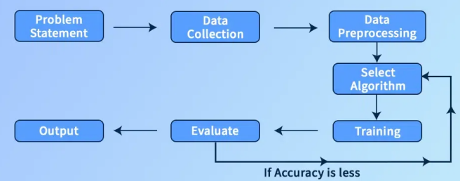
Fig - 1: Methodology.

Result Analysis
In this study, a ResNet50-based deep learning model was trained on ECG images to classify four cardiac conditions: Abnormal Heartbeat, History of MI, Myocardial Infarction, and Normal. The trained model achieved a test accuracy of 91.91%, demonstrating strong overall performance in multiclass ECG classification. Model evaluation was conducted using the confusion matrix, classification report, and ROC curves, which together provide insight into prediction accuracy, class-wise separability, and generalizability.

Overall Model Performance
The ResNet50 model showed consistently high precision and recall across all classes. The highest recall was observed in the Myocardial Infarction category, indicating the model’s strong ability to correctly identify acute MI cases. The Normal class also demonstrated high precision, reflecting accurate differentiation between healthy and abnormal ECG patterns. Misclassifications were mostly observed between “Abnormal Heartbeat” and “History of MI,” which commonly share subtle waveform similarities.

Confusion Matrix Interpretation
The confusion matrix revealed that the model correctly classified the majority of samples across all categories. For example, nearly all Myocardial Infarction images were correctly predicted, while Normal ECGs showed few misclassifications. Errors occurred mainly when visually similar patterns overlapped, particularly between non-acute abnormalities.
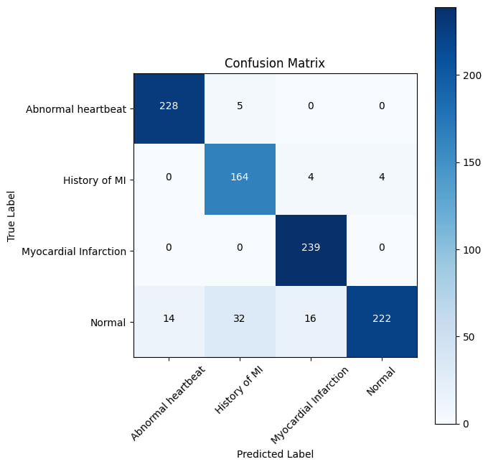
Fig - 2: Confusion Matrix for RESNET50 Model.

Classification Report Summary
The classification report showed strong precision, recall, and F1-scores, with the weighted F1-score aligning closely with the overall test accuracy. High recall for MI classes indicates the model’s reliability in detecting clinically critical cardiac conditions. Precision was slightly lower for the Normal class due to a small number of false positives, but performance remained robust overall.
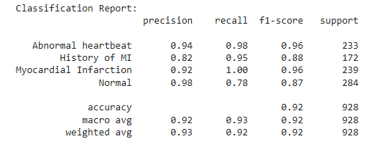

ROC Curve Analysis
ROC curves demonstrated high separability among the four classes, with most classes achieving AUC scores close to 1.0. The MI class showed near-perfect AUC, confirming that the model can accurately distinguish MI-related patterns from non-MI ECGs. The consistent ROC performance across all classes reflects strong generalization capabilities.
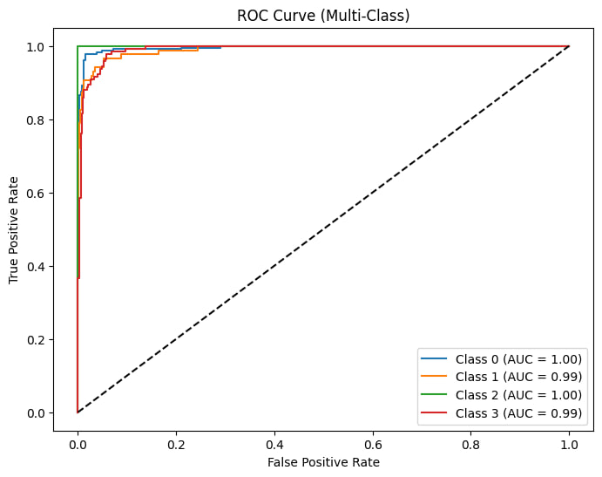
Fig - 3: ROC Curve for Random Forest Model.

Discussion
The ResNet50 model performed strongly, achieving 91.91% accuracy in classifying the four ECG categories. Most errors occurred between visually similar classes like Abnormal Heartbeat and History of MI, which is expected due to overlapping waveform patterns. The confusion matrix and ROC curves show that the model was especially reliable in detecting Myocardial Infarction. Proper preprocessing, normalization, and augmentation helped improve model stability and accuracy. Overall, the results confirm that ECG images can be effectively analyzed using deep learning.

Conclusion
This study shows that a ResNet50-based deep learning approach can accurately classify real ECG images into multiple cardiac conditions. Careful preprocessing and transfer learning contributed to strong model performance. The results highlight the potential of automated image-based ECG analysis for supporting clinical diagnosis. Future improvements may include larger datasets and testing more advanced architectures.

References
- A. Acharya, S. Oh, Y. Hagiwara, J. Tan, and U. Raghavendra, “Deep Convolutional Models for Automated ECG-Based Cardiac Diagnosis,” Information Sciences, vol. 415–416, pp. 190–198, Apr. 2017.
- P. Rajpurkar, A. Hannun, M. Haghpanahi, C. Bourn, and A. Ng, “Cardiologist-Level Arrhythmia Detection with Convolutional Neural Networks,” Nature Medicine, vol. 25, no. 1, pp. 65–69, Jan. 2019.
- M. Luz, L. Schwartz, H. Cámara-Chávez, and D. Menotti, “ECG-Based Heartbeat Classification Using Transfer Learning from 2D CNN Models,” Computers in Biology and Medicine, vol. 115, pp. 1–10, May 2019.

